Inkollu Akashdhar

E-Mail: [akashdhar.apssdc@gmail.com](mailto:akashdhar.apssdc@gmail.com) **Mobile**: 9550835760

 **PRESENT ADDRESS:**

20G/303, Sahara States,

mansoorabad, L.B. nagar,500068.

Looking for a challenging Opportunity in where I can utilize my knowledge and skill for the advancement of the

Company and gaining expertise and building professional career.

**PROFILE SUMMARY**

* **3+ years** of experience in **web application development** using **java** (J2EE) and **spring** framework.
* Worked on projects like biometric based attendance using Aadhaar, Automated Certificate Generation for Colleges, Excel Upload, Designing of UI Components for Reports and Dashboards, storing of data on Cloud using s3, Automated mail service, Writing **queries** for reports.
* Adept in JAVA and Web Applications using **RESTFUL** web Services.
* Conversant with **Html**, **CSS**, **Js**, **Angular**, **IBATIS**, **Spring MVC**, **Spring Boot** and **AWS**.
* Involved in 10+ more projects.

**EXPERIENCE PROFILE**

**Software Engineering**: **July 2018 to Present**

* Currently working in **HCL** as **Full Stack Developer**.
* Working on **Angular7** for building customized components and pages for banking-based applications.
* Optimizations application loading time and design implementations.
* Writing **backend services** and integrating them with UI.
* Creating **Mock API** for UI.

**Junior Software Developer**: **April 2016 to June 2018**

* Worked in **Andhra Pradesh State Skill Development Corporation**.
* Developed application from scratch level using angular and spring.
* Writing basic queries in PostgreSQL.
* Handling deployment and bug fixing.
* Conducted workshop on frontend technologies and AWS.
* Done research on integrating new tech.

**EDUCATION**

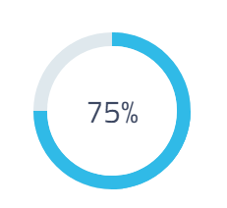 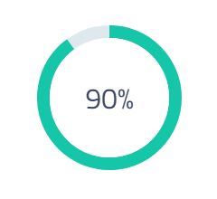 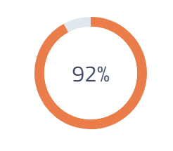

**2012-2016** **2010-2012** **2009-2010**

B. TECH (ECE) INTERMEDIATE HIGH SCHOOL

Avanti Scientific and Research Academy Vikas Junior College Siddhartha High School

**PROJECTS**

**Title** : China Account Opening Service (CNOAOS)

**Client Organization** : DBS

**Environment** : JDK 1.8, Spring Boot, MariaDB, Angular7, IntelliJ

**Team Size** : 3

**Role** : Angular UI Developer

**Description** :

* Need to develop UI pages for the given UX design, integrate and, deploy the production build code for testing

**Responsibility:**

* Need to develop UI pages for the given UX design,
* integrate and, deploy the production build code for testing.

**IT SKILLS**